CHAPTER FOUR

SYSTEM IMPLEMENTATION AND EVALUATION

4.1 Introduction
This chapter discusses the detailed implementation of the Sales Forecasting Model for Inventory and Budget Planning. It bridges the system design discussed in Chapter Three with the actual software application developed. The chapter presents the implementation environment, user interface design, backend architecture, database implementation, forecasting engine, system testing procedures, and evaluation of the forecasting models.

4.2 Implementation Environment
The system was developed and tested using a modern technology stack consisting of frontend, backend, machine learning, and database components. This layered approach promotes modularity, maintainability, and scalability.

4.2.1 Software Requirements
- Operating System: Windows, macOS, and Linux
- Backend Framework: FastAPI (Python 3.9+)
- Frontend Framework: Next.js (React 18)
- Machine Learning Libraries: Scikit-learn, Statsmodels, Pandas, NumPy
- Database: SQLite managed through SQLAlchemy ORM
- Styling and Visualization: Tailwind CSS and Recharts

4.2.2 Hardware Requirements
- Processor: Minimum Intel Core i3 (Core i5 recommended)
- RAM: Minimum 4GB (8GB recommended)
- Storage: Minimum 500MB free disk space

4.3 User Interface Implementation
The user interface was designed to provide a simple and intuitive experience for inventory planners and sales managers. The dashboard enables users to monitor inventory performance, analyze forecast results, and make informed budgeting decisions.

4.3.1 Dashboard Interface
Figure 4.1: Main Dashboard Interface
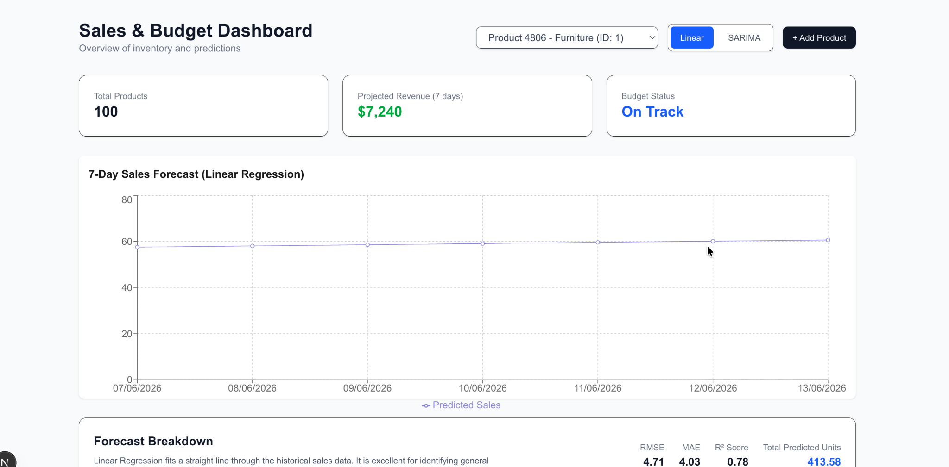
The dashboard shown in Figure 4.1 provides a centralized view of key inventory metrics, projected revenue, budget status, and available products for forecasting. This serves as the primary interaction point for users.

4.3.2 Product Selection Interface
Figure 4.2: Product Selection Interface
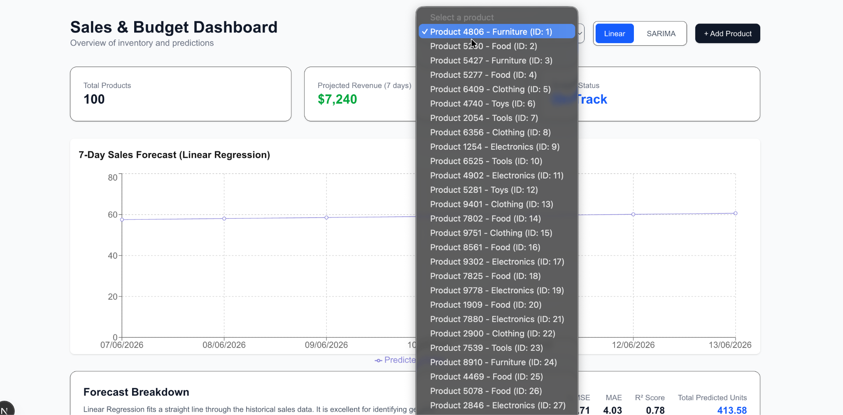
The product selection component allows users to switch between products and retrieve their corresponding historical sales records. Upon selection, the system dynamically updates the forecasting information without requiring a page refresh.

4.3.3 Forecasting Interface
Figure 4.3: Forecast Chart Interface
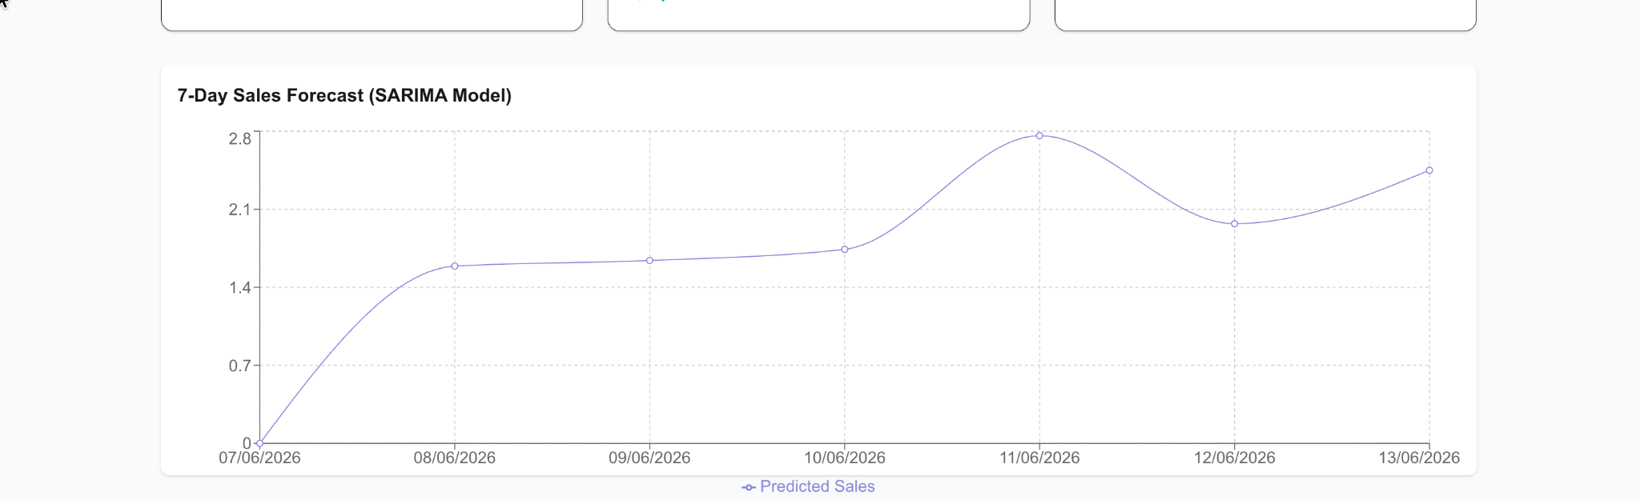
The forecasting interface displays historical sales trends alongside future sales predictions. Users can compare forecasts generated by the Linear Regression and SARIMA models using interactive visualization tools.

4.3.4 Forecast Breakdown Interface

Figure 4.4: Forecast Breakdown Interface
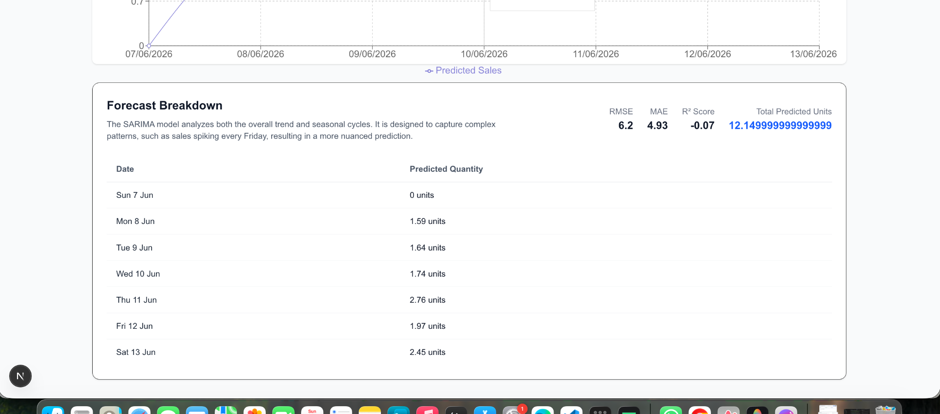

The forecast breakdown section presents detailed prediction results in a human-readable format. It displays daily forecast values, total projected demand, and model evaluation metrics, enabling users to understand the reasoning behind forecast outputs.

4.4 Backend Implementation
The backend layer is responsible for processing requests, managing business logic, interacting with the database, and generating forecasts.

4.4.1 API Development
The backend was implemented using FastAPI, which provides high-performance RESTful APIs for communication between the frontend and backend services.
Key API endpoints include:
Endpoint | Method | Function
/products | GET | Retrieve available products
/products | POST | Add a new product
/sales | POST | Record sales transactions
/forecast | POST | Generate sales forecasts
/budgets | GET | Retrieve budget information

4.4.2 Business Logic Implementation
FastAPI acts as the intermediary between the user interface and the forecasting engine. When a forecast request is received, the system validates the incoming data, retrieves historical sales records from the database, preprocesses the data, and forwards it to the selected forecasting model. The generated forecast is then returned to the frontend for visualization.

4.5 Database Implementation
The database layer was implemented using SQLite and managed through SQLAlchemy ORM. The ORM provides an abstraction layer that allows database operations to be performed through Python objects rather than raw SQL statements.
The database consists of three primary tables:
- Product Table: Stores product details such as product name, category, cost price, selling price, and stock quantity.
- Sale Table: Stores transaction records including product identifiers, quantity sold, total sales amount, and transaction dates.
- Budget Table: Stores budget allocations, spending limits, and expenditure tracking information.
SQLAlchemy automatically manages database relationships, schema creation, validation, and CRUD operations, thereby improving maintainability and reducing security risks associated with manual query handling.

4.6 Forecasting Engine Implementation
The forecasting engine forms the core component of the proposed system. It utilizes two forecasting algorithms to predict future sales demand based on historical sales records.

4.6.1 Linear Regression Model
Linear Regression establishes a mathematical relationship between time and sales quantity. Historical dates are converted into numerical values, enabling the model to identify long-term trends and generate future forecasts.
Forecast Process
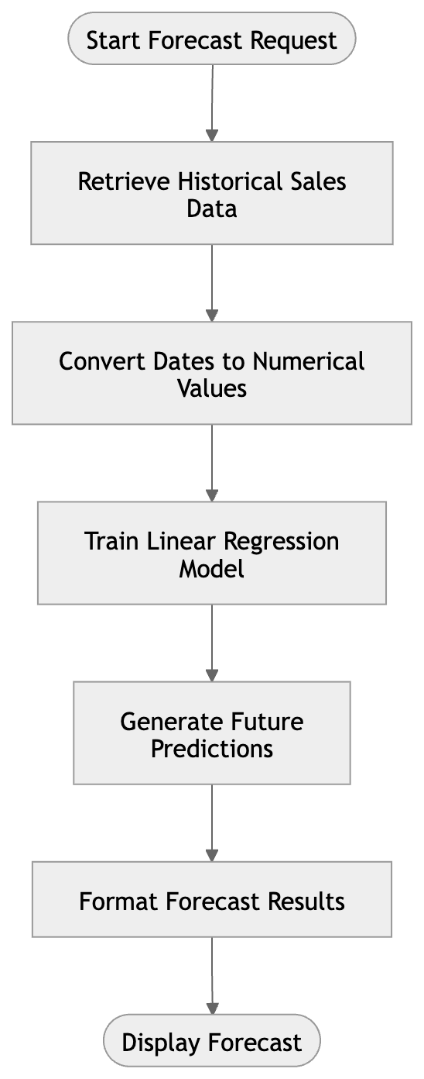

Figure 4.5: Linear Regression Forecasting Process
The model is particularly effective when sales data exhibits a consistent upward or downward trend with minimal seasonal fluctuations.

4.6.2 SARIMA Model
The Seasonal Autoregressive Integrated Moving Average (SARIMA) model captures both trend and seasonal patterns in historical sales data. It is suitable for products whose demand follows recurring cycles.
Forecast Process
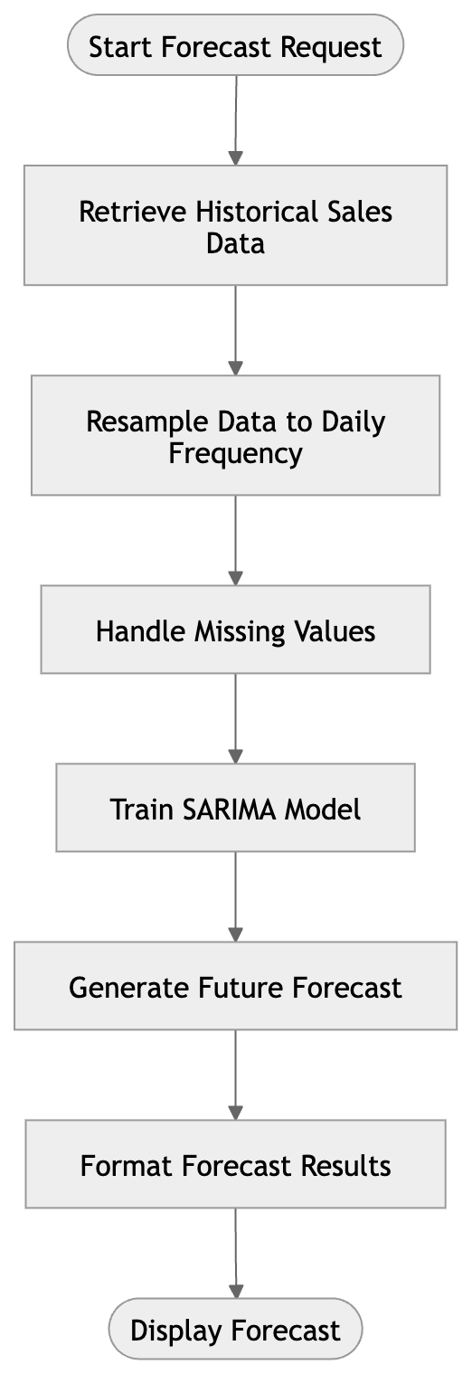
Figure 4.6: SARIMA Forecasting Process
The SARIMA model enhances forecasting accuracy by accounting for seasonal variations and recurring demand patterns.

4.7 Model Evaluation
Since the forecasting engine predicts continuous numerical values, regression evaluation metrics were used to assess model performance.

4.7.1 Root Mean Square Error (RMSE)
RMSE measures the standard deviation of prediction errors and gives higher penalties to larger errors.
RMSE = √[(1/n) Σ(yi − ŷi)²]
Where:
- yi = Actual sales value
- ŷi = Predicted sales value
- n = Number of observations

4.7.2 Mean Absolute Error (MAE)
MAE measures the average magnitude of prediction errors without considering their direction.
MAE = (1/n) Σ|yi − ŷi|
A lower MAE indicates better forecasting accuracy.

4.7.3 Coefficient of Determination (R²)
R² measures the proportion of variance in sales data that can be explained by the forecasting model.
R² = 1 − [Σ(yi − ŷi)² / Σ(yi − ȳ)²]
Values closer to 1 indicate a stronger predictive model.

4.8 System Testing
System testing was conducted to verify that the application met all functional and non-functional requirements.

4.8.1 Unit Testing
Individual modules were tested independently to ensure correct functionality. For example, the forecasting engine was tested to verify that it properly handles insufficient sales history and returns appropriate error responses.

4.8.2 Integration Testing
Integration testing was performed to verify communication between the frontend, backend, database, and forecasting engine. Tests confirmed that API endpoints correctly transmitted and received data.

4.8.3 User Acceptance Testing
The overall workflow of the application was evaluated against the functional requirements defined in Chapter Three.
Table 4.1: System Testing Results
Test Case | Expected Result | Actual Result | Status
Add Product | Product saved successfully | Product saved successfully | Pass
Record Sale | Stock quantity updated | Stock quantity updated | Pass
Generate Forecast | Forecast displayed | Forecast displayed | Pass
Budget Update | Budget information updated | Budget information updated | Pass
Invalid Product Request | Error message displayed | Error message displayed | Pass

4.9 Results and Discussion
To evaluate forecasting performance, the models were tested using a seeded dataset containing 60 days of historical sales records. The generated forecasts were compared against actual values using RMSE, MAE, and R² metrics.
Table 4.2: Forecast Accuracy Results
Model | RMSE | MAE | R² | Training Time
Linear Regression | 4.71 | 4.03 | 0.78 | <0.1s
SARIMA | 7.86 | 5.76 | 0.40 | 0.8s
The evaluation results indicate that Linear Regression achieved better performance than SARIMA on the seeded dataset. The Linear Regression model recorded a lower RMSE and MAE, demonstrating greater forecasting accuracy. This outcome occurred because the generated sales data primarily followed a linear trend and contained limited seasonal variation.
Although SARIMA did not outperform Linear Regression in this experiment, it remains valuable for handling products with recurring seasonal demand patterns. Consequently, the system supports both models, allowing users to select the forecasting approach most appropriate for their data characteristics.

4.10 Summary
This chapter presented the implementation and evaluation of the Sales Forecasting Model for Inventory and Budget Planning. It discussed the system environment, user interface design, backend architecture, database implementation, forecasting engine, and testing procedures. The evaluation results demonstrated that the system successfully generates data-driven sales forecasts capable of supporting inventory replenishment decisions and budget planning activities. The implementation confirms the feasibility of applying machine learning techniques to improve inventory management and forecasting accuracy.

